Risk Management Framework Automated Support Tool

CECOM Software engineering center | 6002 Combat Drive, APG, MD

Graduate Student Report

Marlene Encinas

Jose quinchuela

2016

|  |  |  |
| --- | --- | --- |
| **Revision** | **Date** | **Description of Change** |
| 0.1 | 09/02/2016 | Initial Draft |
| 1.0 | 10/02/2016 | Incorporated sections 1 to 7 |
| 1.1 | 10/15/2016 | Incorporated Data model and finalized functional requirements |
| 1.2 | 10/272016 | Updates for the cover page, table of contents, Implementation Environment and Requirements table and Test Case template, Non-functional requirements |
| 1.3 | 10/30/2016 | Final version |

**Graduate Project Report**

Table of Contents

1. Introduction and Background 4

1a. Background 4

1b. Goals of the Project 4

Project Manager (PM) web application 4

Assessor web application 5

2. Naming Conventions and Terminology 5

2a. Definitions and Acronyms 5

3. The Stakeholders 5

3a. The Client 5

3b. The Customer 5

3c. Other Stakeholders 6

4. Literature Review 6

Implementation Environment of the Current System 6

Use of a database 6

Use of User Interface 7

Web development 8

5. Mandated Constraints 8

5a. Solution Constrains 8

5b. Partner or Collaborative Applications 10

5c. Off the -Shelf Software 10

5d. Anticipated Workplace Environment 10

5e. Schedule Constraints 10

5f. Budget Constrains 10

5g. Enterprise Constraints 10

6. Relevant Facts and Assumptions 11

6a Relevant Facts 11

6b Business Rules 11

7 The scope of the work 12

7a The Current Situation 12

7b The Context of the Work 13

7c Work Partitioning 14

7d Specifying Business Use Case (BUC) 15

8. Business Data Model and Data Dictionary 17

8a Business Data Model 17

8b Data Dictionary 18

9 The Scope of the Product 18

9a Product Boundary 18

9b Product Use Case Table 18

10. Functional Requirements 19

11.Non-Functional Requirements 20

Requirement: Usability 20

Requirement: Ease of use 20

Requirement: Retaining User’s Profile and Preferences 21

Requirement: Performance 21

Requirement: Scalability 21

Requirement: Maintenance 21

12. System Design 22

12.1 ER Schema 22

13. Implementation (Data Flows) 25

14. Test Cases 26

15. Demo (Screenshots) 28

16. Lessons Learned 28

17. Conclusions 28

# 1. Introduction and Background

## 1a. Background

The Department of Defense adopted the execution and maintenance of the Risk Management Framework (RMF) for DoD Information Technology (IT) replacing this way the DoD Information Assurance Certification and Accreditation Process (DIACAP) that was designed to minimize cybersecurity vulnerabilities from all devices connected to DOD networks.

Risk Management is a complex undertaking and can be considered as a holistic activity that is integrated into every aspect of an organization from senior leaders providing a governance structure and strategy to individuals operating and maintaining the systems.

The Risk Management Framework (RMF) is a six-step process, developed by the National Institute of Standards and Technology (NIST) that integrates information security and risk management activities into the system development life cycle. The RMF provides an effective framework for selecting the appropriate security controls for an information system---the security controls necessary to protect organization’s systems. The RMF steps are Categorize, Select, Implement, Assess, Authorize, and Monitor.

During step 2: The project managers (PM) select baseline security controls; apply tailoring guidance and supplement controls as needed based on risk assessment

During Ste 3: Implement, the PM implement security controls within enterprise architecture using sound systems engineering practices; apply security configuration settings

During the Step 4: Assess, the assessors evaluate manually around 860 security controls for a determined system in a 30-day required time frame.

## 1b. Goals of the Project

Currently, the exchange of information between the assessors and systems owners is by email. Assessors receive required artifacts by email, usually creating big file size email; assessors create their evaluation documents using spreadsheets; the whole evaluation result is input manually in the spreadsheets, and sent to the system owner by email. The goal of this project is to deliver an automated web tool to support the assessors by providing a shared repository to exchange artifacts, contains relevant metadata regarding the controls. This way the assessors and system owners would have a broader picture of a program‘s evaluation that goes beyond the traditional compliance focus; it will aid assessors and system owners in making informed decisions regarding effectiveness, cost and relevance of the mitigations in different environments and different threat settings.

### Project Manager (PM) web application

The web application for the Project Manager will capture the controls to be selected and implemented during phase 2 - Select and phase 3 - Implement of the RMF. This controls will be stored in a shared database with the Assessors. In addition, the web application will allow to upload additional documentation necessary to build the package to be submitted to the assessor. The web application will allow to submit the package to the assessor and generate a Plan of Actions and Milestones (PO&M).

### Assessor web application

The Assessor web application will list the projects to be assessed, will allow the assessor to select a project to be evaluated, input an assessment on the controls that the PM has selected. This web application will use the same shared database that the Project Manager web application. After assessors finalizes his assessment, it will generate a final assessment report

# 2. Naming Conventions and Terminology

## 2a. Definitions and Acronyms

**Authorizing Official (AO):** is a senior federal official or executive who assumes the responsibility for an Information System (IS) at acceptable level of risk and will be reviewing the Security Assessment Plan and the Assessor’s recommendation documentation.

**AO Direct Representative (AODR):** Acts on behalf of an authorizing official to coordinate and conduct the required day-to-day activities associated with the security authorization process.

**IS:** Information System

ISO: Information System Owner. Official responsible for the procurement, development and maintenance of a system

**RMF:** Risk Management Framework

**Risk Assessment**: The process of identifying, prioritizing, and estimating risks.

**SCA -V:** The security control assessor validator is an individual, group, or organization responsible for conducting a comprehensive assessment of the management, operational, and technical security controls employed to determine the overall effectiveness of the IS implementation controls and recommend system’s accreditation.

**System Owner (SO):** Response bile for the procurement, development, integration and maintenance and disposal of an IS. After reducing or eliminate vulnerabilities, the SO submits the package to the authorizing official or the authorizing official designated representative for adjudication.

# 3. The Stakeholders

## 3a. The Client

Software Engineering division is sponsoring the RMF tool and will approve the final system delivery (product) to ensure is built according to business requirements.

## 3b. The Customer

The SCA -V assessment team (users of the system) is the customer that designates a representative to witness the validation and verification of the product when it is delivered to the client. This person has the authority to accept or reject the final product.

## 3c. Other Stakeholders

The SCA-V Chief Cyber Security will be generating a final recommendation letter based on the RFM on the RMF assessment results

The Bid Evaluator evaluates the bids on the requests for RMF assessment submitted by the assessor.

The Authorizing Official (AO) or is AO Direct Representative (AODR) is a senior federal official or executive who assumes the responsibility for an Information System (IS) at acceptable level of risk and will be reviewing the Security Assessment Plan and the Assessor’s recommendation documentation.

# 4. Literature Review

## Implementation Environment of the Current System

This section describes the technological and physical environment in which the product is to be installed. It describes several potential solutions and their advantage and disadvantage of using it:

### Use of a database

|  |  |  |
| --- | --- | --- |
| **Database Type** | **Advantage** | **Disadvantage** |
| Relational Database | * Ease to Use for the customer * Flexibility * Use of security Controls such as user authentication | * Very common to databases: Physical Storage and Performance |
| Distributed | * Reduce the effort in data communications * Minimize Costs * Reduce local control of information and allows flexibility and ease of transfer. | * Adds to complexity and cost if the data has to be shared across multiple platforms * Processing overheads * Data Integrity |
| Centralized | * Increased reliability and availability * Modular (incremental) growth * Lower communication costs * Faster Response | * Database is in one central location and can be difficult to access it. * Not flexible to recover from a loss of information. |

### Use of User Interface

|  |  |  |
| --- | --- | --- |
| **User Interface Options** | **Advantage** | **Disadvantage** |
| Object Oriented | * provides better productivity for the user by easily maintaining and sustaining good code development practices * Provides better ways to encapsulate objects with their respective functions. * provides a good library collection for the user to easily apply to code providing a steady supply of software components | * Unexpected complex interaction with interfaces when writing the code. * Different classes types from different libraries makes it almost difficult to interact with newly objects created. |
| Structured Program | * Increase productivity by providing a flexible structure for users to work on different components of the program * Easy to modify due to the use of individual components. * Logical structures ensure clear flow of control. * Modules can be re-used many times, thus it saves time, reduces complexity and increase reliability. | * Lack of encapsulation for single components * Duplication of Code. * Lack of information hiding. * Change in one component may change the structure of the program, making more changes in other parts of the program. * Needs better code development and refactor practices to maintain the code. |
| Scriptlets |  |  |
| Model- View -Controller | * Provides alternative ways in the creation of user interfaces for one or two models. * Provides different views with connection to different controllers of the same model * Provides a way to easily manage user interfaces and their respective views in the application by separation of tasks. * Automated testing is easier to use with MVC because of the encapsulation of its components   . | * A little difficulty in upgrading other web services frameworks with MVC. * Changes made to View and Controller can affect the overall performance of the UI if not taken into consideration. * Changes to the Model will change interaction between Controller and View. * Routing of Controllers and View has to be done carefully or the user will encounter an error. |

### Web development

|  |  |  |
| --- | --- | --- |
| **Web Development Options** | **Advantage** | **Disadvantage** |
| Java Server Pages, Servlets |  |  |
| ASP.Net MVC 5 |  |  |
| Ruby on Rails |  |  |

# 5. Mandated Constraints

## 5a. Solution Constrains

These are constraints that should describe any mandated designs or solutions. Solution constraints specify how a problem must be solved.

Description: The software shall operate on a Windows 10 operating system.

Rationale: The client uses a Windows 10 OS and will not use any other.

Fit Criterion: The product shall be approved as Windows 10 compliant by our testers.

Description: The software shall operate on desktop and laptop computers only.

Rationale: The client uses laptops and desktop computers.

Fit Criterion: The product shall be approved to be used on Army laptop and desktop computers through their accreditation and certification process.

Description: The software shall use a database to store all documentations

Rationale: The client requires a common shared repository for storing data.

Fit Criterion: All data should be shared and stored using and automated technology.

Description: The assessment team will be presented with a GUI to choose and evaluate security controls

Rationale: The client requires an automatic selection of security controls during the assessment process.

Fit Criterion: The product will use GUI that can be automatically in any screen size.

## 5b. Partner or Collaborative Applications

This section describes the applications that will communicate with the software but are not part of the product.

Microsoft Office – Any report generated flight will be printed as a Microsoft Word or Excel file.

## 5c. Off the -Shelf Software

This section describes any commercial and open-source software used in the implementation of the product. The COTS products are MS Visual Studio 2015, SQL Server 2016 and MS Visio, MS Project

## 5d. Anticipated Workplace Environment

All users will be accessing the system using a computer in the office workplace environment of the network. Printers are located in the office network.

## 5e. Schedule Constraints

The assessor has 30 days to assess a project since he formally start his assessment and provide his final recommendation.

## 5f. Budget Constrains

There is not funding provided to develop this project.

## 5g. Enterprise Constraints

This section contains requirements that are specific to the enterprise that required the IS.

Description: The System shall be usable after completion of one (1) hour of training.

Rationale: The client requested that the system be intuitive for assessors

Fit Criterion: The System shall be usable after reviewing a user manual

Description: The System shall provide all information to support work processes in electronic format and also allow hard copy production of documents.

Rationale: The client requested that the system be paperless, but provide a means to print hard copies of documents.

Fit Criterion: The System shall support the accomplishment of user’s tasks, without any printed documents.

Description: The System shall allow a user to reach a feature with no more than three (3) input operations.

Rationale: The client requested that the system implement a User Interface (UI) that is easy to navigate.

Fit Criterion: The System shall allow a user to reach their desired feature with no more than three (3) input operations.

# 6. Relevant Facts and Assumptions

## 6a Relevant Facts

* The current assessment process is managed through an exchange of Excel spreadsheets via email.
* The information result from the security control assessment can be used to identify potential problems, prioritize risk mitigation decisions, support continuous monitoring, facilitate security authorization decisions.
* **SP800-53A** provides a set of procedures that can be easily tailored for conducting assessments of security controls.
* Security and privacy assessment are carried out in all software development life cycle phases (SLDC).

## 6b Business Rules

* The assessor shall be independent to the organization and provide an impartial assessment.
* The selection of appropriate procedures depends on:
  + Security Categorization of the system
  + Assurance Requirements of the organization to defining the overall control effectiveness.
  + Security Controls from SP800-53 as identified in the Security Plan (SP) and Privacy Plans.
* Security Assessment Plan (SAP) provides the objectives for the security control assessment and a detailed roadmap of how to conduct such an assessment. A SAP is developed based on the SP800-53A, Privacy Plan and Security Plan (SP).
* An assessment procedure consists of a set of assessment objectives, each with a set of potential assessment methods and assessment objects.
  + Assessment objectives are statements linked to a control content to ensure traceability of assessment results back to control requirements. Applying an assessment procedure to a control produces assessment findings.
  + Assessment objects: Identify specific items being assessed. It includes:
    - Specifications: Are the artifacts associated with a system (e.g. policies, procedures, plans, security and privacy requirements, specifications, design)
    - Mechanisms: Are specific HW, SW safeguards and countermeasures used within a system
    - Activities: Protections actions supporting a system (backup operations, monitoring, network, etc.)
    - Individuals: - Personnel applying specifications and activities.
  + Assessment methods (SP800-53 Appendix D):
    - Can be:
      * Examination: observing, inspecting one or more assessment objects
      * Interviewing
      * Testing: exercising assessment objects under specified conditions with expected behavior
    - Have attributes: depth and coverage that help define the level of effort of the assessment
      * Depth: identifies how profound the assessment method will be (rigor and detail): Values are: basic, focused, and comprehensive.
      * Coverage: identifies the scope of the assessment method. Values are: basic, focused, and comprehensive.
* SAR: Security Assessment Report: Documents weaknesses and deficiencies that could not be resolved and recommendations. A SAR is always required before an authorization decision.
* If no vulnerabilities are found, the controls are recorded as **Compliant** in the **SAR**
* **The non-compliant (NC) or non-applicable (NA) controls** are recorded in the **Plan of Actions and Milestones (POA&M).**
  + **The NC have vulnerability severity values**
* The remediation actions include conducting initial remediation actions on the findings and recommendations on the SAR.
* The Authorization Package consists of: Updated SP, SAR and Updated POA&M

**5c Assumptions**

* The Organizational preparation to the Assessment process assumes that:
  + Policies covering control assessment are in place and understood by all
  + RMF steps 1- 4 are completed
  + Objective and scope of assessment are established
  + Time frames conducting assessments and key milestone decision points are identified
  + Assessment team has been identified
  + Assessment team has received all artifacts to be assessed

# 7 The scope of the work

## 7a The Current Situation

The below swimlane diagram shows an analysis of the existing business processes including manual and automated processes.

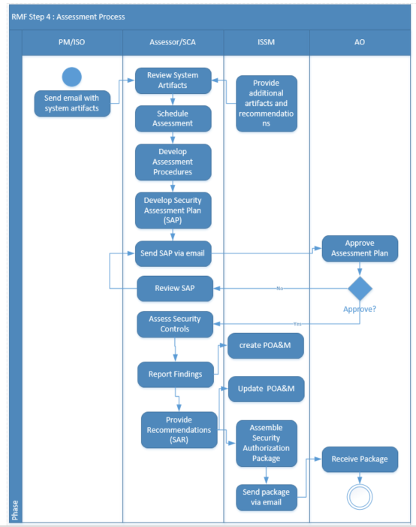

## 7b The Context of the Work

The following is a Context Diagram that identifies the boundaries of the work to be in research.

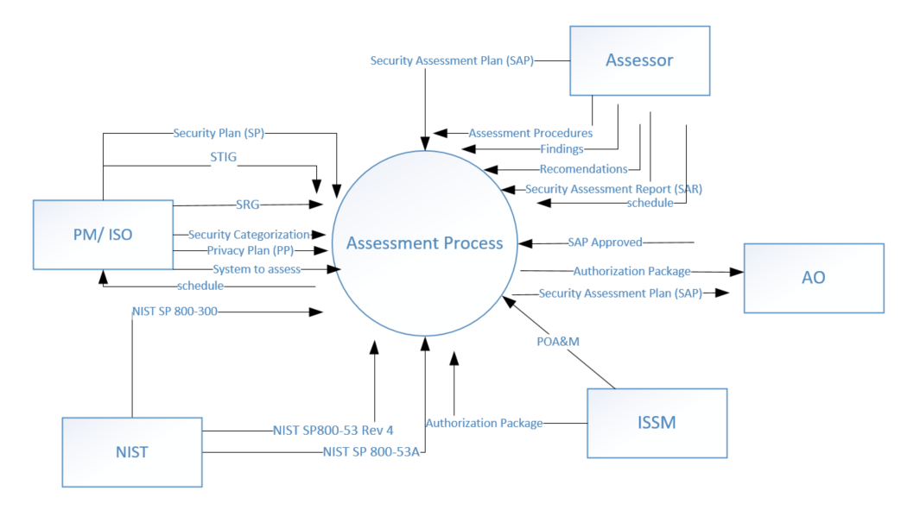

## 7c Work Partitioning

The following is a Business Event List

|  |  |  |
| --- | --- | --- |
| **Event Name** | **Input and Output** | **Summary of BUC** |
| 1. PM or ISO submits a system | System to assess (in) | Record system details |
| 1. PM/ISO submits artifacts | System’s supporting artifacts (SP), security categorization, Privacy Plan, Assurance Requirements (in)  schedule(out) | Prioritize and Schedule system |
| 1. PM/ISO submits system’s supporting artifacts | System’s supporting artifacts (SP), security categorization, Privacy Plan, Assurance Requirements (in)  Assessment procedures (out) | Assessor Records assessment procedures |
| 1. PM/ISO submits system’s supporting artifacts | Security Plan (SP) (in),  Security categorization (in), Privacy Plan (in),  Assurance Requirements (in),  schedule(in),  Assessment procedures (in),  NIST SP800-53 Rev 4 (in),  NIST SP 800-300 (in),  SP 800-53A (in),  SAP(out) | Develop SAP |
| 1. Assessor submits SAP | SAP(out) | Obtain AO Approval |
| 1. AO approve SAP | Approved SAP (in),  SP 800-53A (in),  DODI 8510.01 (in),  STIG (in),  SRG (in),  Findings (out) | Assessor assess security controls |
| 1. Assessor submits findings | Findings (in) | Assessor create SAR |
| 1. Assessor provides recommendations | Recommendations (in) | ISSM create POA&M |
| 1. Assessor provides recommendations | Recommendations (in)  Findings (in)  Security Authorization Package (out) | ISSM assemble Security Authorization Package |

## 7d Specifying Business Use Case (BUC)

The following is a specification of the details of how a Business Use Case (BUC) responds to a Business Event.

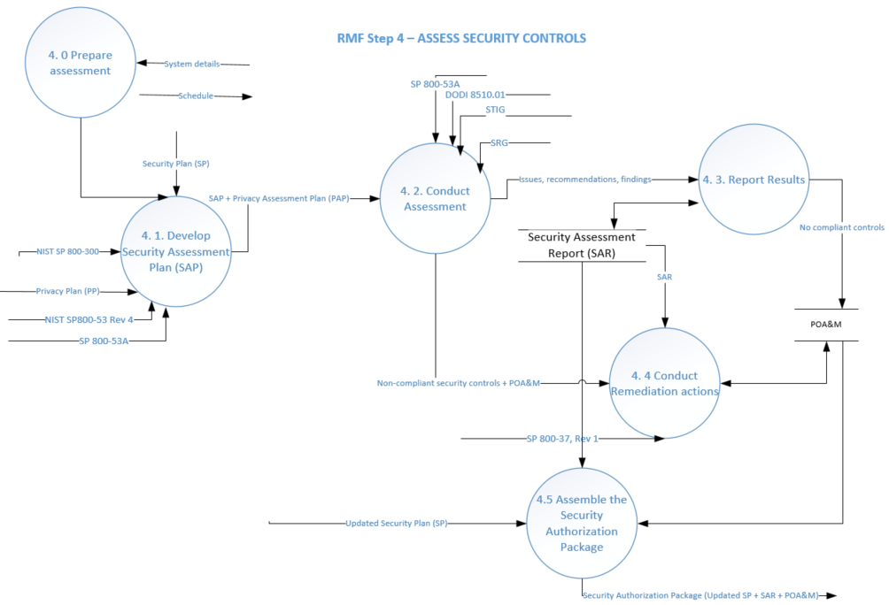

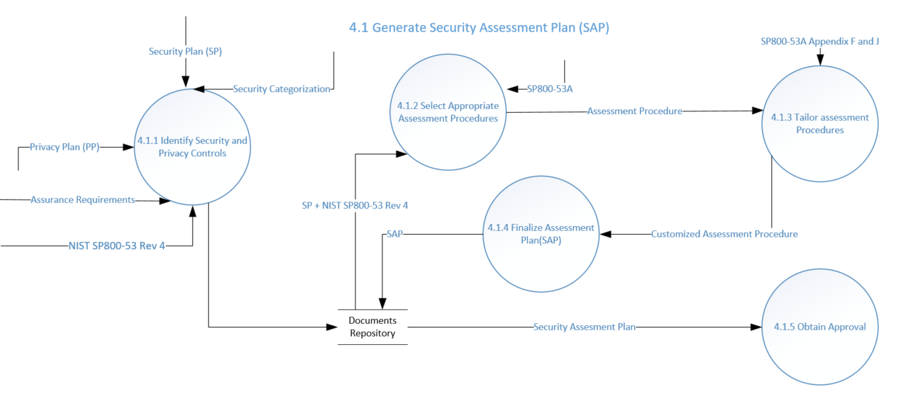

# 8. Business Data Model and Data Dictionary

## 8a Business Data Model



## 8b Data Dictionary

# 9 The Scope of the Product

## 9a Product Boundary

Below is a use case diagram that identifies the boundaries between the users (actors) and the product

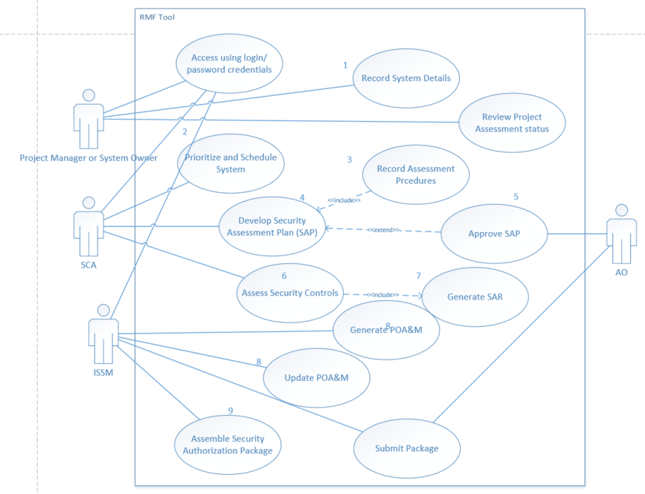

## 9b Product Use Case Table

|  |  |  |  |
| --- | --- | --- | --- |
| PUC | PUC Name | Actor/s | Input and Output |
| 1 | login with username and password | all | Login(in)  Password (in) |
| 2 | Register user who request access to the RMF Automated Support Tool (RAST) | all |  |
| 3 | Register a system for assessment | Project Manager/ISO | System info (in) |
| 4 | Associate system with baseline controls | Project Manager/ISO |  |
| 5 | Associate system with additional controls | Project Manager/ISO |  |
| 6 | Display assessment status | RAST tool | System assessment status detail (out) |
| 7 | Assign priority to a system to assess | SCA | Priority level (in) |
| 8 | Assign schedule to a system to assess | SCA | Schedule details (in) |
| 9 | Record Security Assessment Plan (SAP) | SCA | SAP (in) |
| 10 | Approve SAP | AO | Approval (in) |
| 11 | Input security control assessment results | SCA | Finding (in) |
| 12 | Record Security Assessment Report (SAR) | SCA | SAR(in) |
| 13 | Record POA&M | ISSM | POA&M (in) |
| 14 | Submit Security Authorization Package | ISSM | Security Authorization Package (out) |

# 10. Functional Requirements

Table 1 - User Requirements

|  |  |  |  |
| --- | --- | --- | --- |
| ID | User Requirement | Where Elicited From | Type of Requirement |
| 1 | The product shall authenticate the user through use of username and password | Observation of existing process and reading documentation | Functional Requirement |
| 2 | The product shall identify if the user is project manager (System Owner), SCA team, SCA, ISSM or AO | Observation of existing process and reading documentation | Functional Requirement |
| 3 | The product shall register user who request access to the RMF Automated Support Tool (RAST) for first time | Observation of existing process and reading documentation | Functional Requirement |
| 4 | The product shall register a system for assessment | Observation of existing process and reading documentation | Functional Requirement |
| 5 | The product shall allow to associate system with baseline controls | Observation of existing process and reading documentation | Functional Requirement |
| 6 | The product shall allow to associate system with additional controls | Observation of existing process and reading documentation | Functional Requirement |
| 7 | The product shall display assessment status | Observation of existing process and reading documentation | Functional Requirement |
| 8 | The product shall assign priority to a system to assess | Observation of existing process and reading documentation | Functional Requirement |
| 9 | The product shall assign schedule to a system to assess | Observation of existing process and reading documentation | Functional Requirement |
| 10 | The product shall record Security Assessment Plan (SAP) | Observation of existing process and reading documentation | Functional Requirement |
| 11 | The product shall allow to approve SAP | Observation of existing process and reading documentation | Functional Requirement |
| 12 | The product shall allow to input security control assessment results | Observation of existing process and reading documentation | Functional Requirement |
| 13 | The product shall allow to record system artifacts | Observation of existing process and reading documentation | Functional Requirement |
| 14 | The product shall record Security Assessment Report (SAR) | Observation of existing process and reading documentation | Functional Requirement |
| 15 | The product shall record POA&M | Observation of existing process and reading documentation | Functional Requirement |
| 16 | The product shall allow submission of the Security Authorization Package | Observation of existing process and reading documentation | Functional Requirement |

# 11.Non-Functional Requirements

## Requirement: Usability

Description: The upload of a file shall be according to file size.

Rationale: User requires attempting to upload a reviewed document, plan or report.

Fit Criterion: A user shall choose to upload a file(s) with their request. The size of each file must be less than 20 MB. The reviewer may download and view each file.

## Requirement: Ease of use

Description: The product shall be intuitive, easy to use and navigate for all users.

Rationale: The assessor and project manager require an efficient means for putting through RMF requests to reduce time spent doing it manually by themselves.

Fit Criterion: The assessor and project manager shall be able to submit their request (online website) successfully using a GUI.

## Requirement: Retaining User’s Profile and Preferences

Description: The product shall retain the user’s personal profile and preferences.

Rationale: The customer requires that the product be configured to allow user the capability to save personal profile preferences such as organization’s name, work email, phone number, personal configuration options, etc. to his or her profile as a convenience for future reference.

Fit Criterion: The user shall be able to save his or her personal preferences regarding personal configuration options so he or she can easily access it at a later time.

## Requirement: Performance

Description: The product shall be able to perform user specified tasks within a 60 seconds response time.

Rationale: The customer requires that the product be built to respond to user specified tasks within a 60 seconds response time and that the latency between tasks shall not exceed 60 seconds.

Fit Criterion: The product shall respond in less than 60 seconds when users are logged into the system and performing a sequence of tasks and that the response time between tasks should take no longer than 60 seconds. The success rate shall be on average 90 percent of the time.

## Requirement: Scalability

Description: The product shall be able to handle an increase of users without causing product degradation.

Rationale: The customer continually hires new employees yearly as their client base expands shall result in the product’s ability to handle users accessing the product simultaneously without experiencing any performance issues.

Fit Criterion: The product shall be able to scale up from 1 users to 3 to 10 users without any product degradation being experienced by the users.

## Requirement: Maintenance

Description: The product shall be built to be maintainable. The product must be able to be maintained by its end users. The Risk Management Framework Team Administrator will be in charge of this.

Rationale: The client has required that there be maintenance for different browser of the system, making sure the product can migrate to different platforms as required.

Fit Criterion: The product shall be able to transition from clients’ personal environment to a general server environment or to a different platform to be maintained when it would be necessary.

Table 2 – Non-Functional Requirements

|  |  |  |  |
| --- | --- | --- | --- |
|  | **User Requirement** | **Where Elicited From** | **Type of Requirement** |
| 17 | The upload of a file shall be according to file size. | RMF Book | Non-Functional Requirement |
| 18 | The product shall be intuitive, easy to use and navigate for all users. | RMF Book | Non-Functional Requirement |
| 19 | The product shall retain the user’s personal profile and preferences. | RMF Book | Non-Functional Requirement |
| 20 | The product shall be able to perform user specified tasks within a 60 seconds response time. | RMF Book | Non-Functional Requirement |
| 21 | The product shall be able to handle an increase of users without causing product degradation. | RMF Book | Non-Functional Requirement |
| 22 | The product shall be built to be maintainable. The product must be able to be maintained by its end users. The Risk Management Framework Team Administrator will be in charge of this. | RMF Book | Non-Functional Requirement |

# 12. System Design

## 12.1 ER Schema



Table 2 - Breakdown of Technologies Used in Design

|  |  |  |  |  |  |
| --- | --- | --- | --- | --- | --- |
|  | **User Requirement** | **Where Elicited From** | **Type of Requirement** | **Design Decision & Technology Used** | **Why?** |
| 1 |  | BUC | Functional Requirement | ERD, Object Oriented design, MVC web development Framework, C# programming language | Because of its advantages. See Implementation table. |
| 2 |  | BUC | Functional Requirement | ERD, Object Oriented design, MVC web development Framework, C# programming language | Because of its advantages. See Table 1 |
| 3 |  | BUC | Functional Requirement | ERD, Object Oriented design, MVC web development Framework, C# programming language | Because of its advantages. See Table 1 |
| 4 |  | BUC | Functional Requirement | ERD, Object Oriented design, MVC web development Framework, C# programming language | Because of its advantages. See Table 1 |
| 5 |  | BUC | Functional Requirement | ERD, Object Oriented design, MVC web development Framework, C# programming language | Because of its advantages. See Table 1 |
| 6 |  | BUC | Non-Functional Requirement | ERD, Object Oriented design, MVC web development Framework, C# programming language | Because of its advantages. See Table 1 |
| 7 |  | BUC | Non-Functional Requirement | ERD, Object Oriented design, MVC web development Framework, C# programming language | Because of its advantages. See Table 1 |
| 8 |  | BUC | Non-Functional Requirement | ERD, Object Oriented design, MVC web development Framework, C# programming language | Because of its advantages. See Table 1 |
| 9 |  | BUC | Non-Functional Requirement | ERD, Object Oriented design, MVC web development Framework, C# programming language | Because of its advantages. See Table 1 |
| 10 |  | BUC | Non-Functional Requirement | ERD, Object Oriented design, MVC web development Framework, C# programming language | Because of its advantages. See Table 1 |
|  |  | BUC | Non-Functional Requirement | ERD, Object Oriented design, MVC web development Framework, C# programming language | Because of its advantages. See Table 1 |

# 13. Implementation (Data Flows)

# 14. Test Cases

|  |  |  |  |  |  |
| --- | --- | --- | --- | --- | --- |
| **Test Case #1** | | | | | |
| **Test Case #: 1.1**  Verify the user profile | | **Version Date:** | **Tester Name:**  **Test Date:** | | **Primary Requirements#1:** |
| **System:** | | **Environment:** Desktop Component | **Execution Date:** | | **Pass/Fail (IE64):** |
| **Test Case Description:**  This scenario is designed to test verification of the user profile accurate. | | | | | |
| **Test Data Description:**  This test scenario can be executed by any registered user with a valid login linked to an account in the test environment. | | | | | |
| **Test Setup/Prerequisites:**  User has successfully logged in to the FDM web site in the test environment. | | | | | |
| **Test Case Procedures** | | | | | |
| **Step**  **#** | **Test Action** | **Expected Results** | **Actual Results** | **Pass/**  **Fail** | **Comments** |
| 1 | Login to FDM. | The **Financial Disclosure Management** page is displayed. |  |  |  |
| 2 | Select the **My Info** tab and **My Profile** sub-tab. | The **My Profile** page is displayed.  Information shown contains all the roles the user has been assigned, General Org Unit Information, Filer assistants if any, an Edit Logins button and an Audit Trail button. |  |  |  |
| 3 | In the **My Roles** block click on each role for further details. | The **My Profile** page is redisplayed. **I am a member of Org Unit <org unit>** is displayed. |  |  |  |
| 4 | Under **General Org Unit Information** click on the org unit listed. | The **Org Unit Profile** pop-up is displayed. Information shown includes: Name, Description, Org Unit Location, Org Unit POC(s), Supervisor, 450 Certifier, SLC and DAEO. |  |  |  |
| 5 | Click on any name shown for any position assigned. | The **Directory lookup Details for <name>** are shown. Not all Attributes may have a Value. |  |  |  |
| 6 | Click on **Close**. | The **Org Unit Profile** is redisplayed. |  |  |  |
| 7 | Click on **Show Filers**. | A pop-up with **Filers for Org Unit: (name)** is displayed**.** Or a pop-up that states: Unauthorized, You are not authorized to view this page. |  |  |  |
| 8 | Click on the **X** in the upper right corner. | The **My Profile** page is displayed |  |  |  |
| 9 | Under **General Org Unit Information** click on the org unit listed. | The **Org Unit Profile** pop-up is displayed. |  |  |  |
| 10 | Click **Audit Trail.** | A pop-up with the **Audit Trail History of <org unit>** is displayed.  Note: Audit Trail pop-ups also contain a **Print** button. Follow normal procedures to print pages if required. |  |  |  |
| 11 | Click on **Close.** | The pop-up closes and **My Profile** page is displayed. |  |  |  |
| 12 | Click on **Edit Logins.** | The **Login Credentials for <name>** is displayed. Verify your login credentials are listed. There may be more than one listed. |  |  |  |
| 13 | Click on the **?How Do I…** blue button, | A new window opens up with directions for **Adding a Login Credential**. |  |  |  |
| 14 | Close the window. | The **Login Credentials for <name>** is displayed. |  |  |  |
| 15 | Click on **Back**. | The **My Profile** page is displayed. |  |  |  |
| 16 | Click on **Audit Trail**. | A pop-up of the **Audit Trail History of <name>** is displayed. Review the audit trail.  Note: Audit Trail pop-ups also contain a **Print** button. Follow normal procedures to print pages if required. |  |  |  |
| 17 | Click on **Close.** | The pop-up closes and **My Profile** page is displayed. |  |  |  |
|  |  |  |  |  |  |
|  |  |  |  |  |  |
|  |  |  |  |  |  |

|  |
| --- |
| **Post-conditions:**  1. The value has changed  2. Courses have changed. |

# 15. Demo (Screenshots)

# 16. Lessons Learned

We could’ve taken an automated approach to testing using Coded UI but the team didn’t have time plus it would’ve involved more coding time.

# 17. Conclusions